Search Results

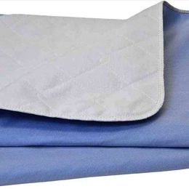

$10  
New Incontinent Bed Pads  
Greensburg, IN  
New Incontinent Bed Pads. I have dozens. Super absorbent. Excellent for changing tables,cribs, toddler beds, elderly, and dog beds. Keep one in your diaper bag to change baby on the go.

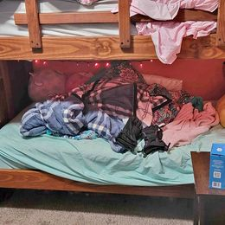

$150  
$300  
Marked Down Wooden bunk bed  
Greensburg, IN  
I listened it back in December but my son got to sick in with hospital wise and then I got sick and I was hospitalized . And now we're both better and my husband wants the bunk bed out of the garage.Wooded bunk bed, four small storage drawers on the sides. This is a no smoking house. CASH only to purchase please. It was use every other weekend so in great condition 300 or best offer. The girls just wanting new full size bed. Need to get rid of it fast.